Community Dumpsters!

We will be having our community dumpsters on May 13th, 14th, & 15th from 1 p.m. to 5 p.m. and on May 16th from 9 a.m. to 2 p.m. for Paint Brush Hills residents. The dumpsters will be located at our pump house off of Londonderry, just west of Beckham Street on the left. You will need your ID and PBH water bill for proof of residency.

Items that CAN NOT be dumped:
-Any items containing freon (A/C’s, Freezers, Refrigerators, etc.)
-Mattresses ($100 charge per mattress)
-Tires
-Batteries
-Computer components/TV’s
-Paint, oil, chemicals, hazardous materials
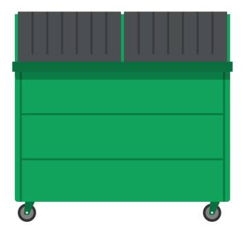
-Compressed gas containers (O2 tanks, etc.)
-Asbestos

